*Ver. 08.02.2023 (previous version: 30.8.2018)*

**STEP-BY-STEP GUIDE TO HARVEST PLOTS**

**IMPORTANT:** Sample from/harvest **ONLY** **Control plots** (sprayed + unsprayed) **and Weeded plots** (sprayed + unsprayed) – total **four plots** per garden.

1. **Evaluate vegetation coverage of a plot.**
2. **Collect DBH for bigger trees. Cover them with mosquito net and cut them down first.**
3. **Collect insects from each tree. No need to collect separately from individual plant species.**
4. **Cover parts of the remaining mixed vegetation with mosquito net and cut it down part by part.**
5. **Collect insects from each batch of a mixed vegetation.**
6. **Insect from a single plot can be pooled together.**
7. **Label the insect container: the firs label in the vial, and the second taped to the side.**
8. **Sort all harvested vegetation into species.**
9. **For woody plants take a stem and leaf weight separately.**
10. **Fill biomass data-sheet with species ID and weight.**
11. **Evaluate which species make up 80% of total LEAF BIOMASS (in case of woody plants) or TOTAL BIOMASS (in case of non-woody plants).**
12. **For the selected species collect leaf frames (1 per species) and leaf disks (5 per species).**

**DETAILED EXPLANATIONS**

**1. Evaluate vegetation coverage of a plot**

* For a plot that is about to be harvested first make a standard cover sampling of vegetation.

**2. Cover bigger trees with mosquito net and cut these first.**

* Bigger trees needs to be sampled first to allow for further sampling of mixed vegetation
* Collect DBH of all individuals that have DBH above 1 cm.

**3. Cover parts of the remaining vegetation with mosquito net and cut it down in mixed batches.**

* It's important to select a section of the vegetation so that during cutting, the rest of the vegetation isn't disturbed too much.

**4. Collect insects from each woody plant and batch of mixed vegetation.**

* Knock-down insects with MORTEIN and collect specimens.
* No need to sample separately from individual plant species (you can pool insects sampled from various plant species).

**5. Label the insect container.**

* The firs label should go into the vial with ethanol. The second taped should be taped to the side of the vial.

**6. Sort all harvested vegetation into species.**

* Fill in the biomass data sheet.
* **FILL ALL BOXES FOR EACH SPECIES TRAITS**!: **Life forms**: tree, shrub, herb, fern etc.; **Pubescence**: 0 – no hairs, 1 – some hairs, 2 – abundant hairs; Latex (sap): 0 – no latex, 1 – latex present.

**7. For woody plants weight stem and leaves separately.**

* For woody plants separate stem from leaves and weigh each separately.

**10. Evaluate which species make up 80% of total of LEAF biomass.**

* Use provided spreadsheet to get species for leaf frames:
  + Clear out ‘**Species**’ and ‘**Biomass**’ columns.
  + Fill the ‘**Species**’ column with species name or code and ‘**Biomass**’ column with values in kilograms. **Order is not important**.
  + When you finish species for which a leaf frame is supposed to be taken displays in the green column: ‘**Species to include**’.
* **In case of a problem with a computer here is an example how to perform this manually**:
  + write down species names and ONLY LEAF biomass in a separated data-sheet. For example:
    - *Macaranga aleurotoides* – 5.987 kg (leaf biomass)
    - *Piper aduncum* – 1.233 kg (leaf biomass)
    - *Paspalum conjugatum* – 10.341 kg (total biomass)
    - *Ageratum conyzoides* – 0.564 kg (total biomass)
  + Add all the weighs (18.125 kg in this example): 5.987 + 1.233 + 10.341+ 0.564 = 18.125
  + calculate how much biomass makes up to 80%: multiply the value by 0.8: 18.125 x 0.8 = 14.5 kg.
  + Look for the highest weight. Here it would be *Paspalum conjugatum* 10.341.
  + If that value is smaller than 80% of biomass you add this species to a list of plants for the SLA sample and look for a next highest weight. That would be *Macaranga aleurotoides* with 5.987 kg.
  + Include that species in the list as well and add its weight to the previous one. The sum is: 10.341 + 5.987 = 16.328 kg. This is now higher than 80% weight (14.5 kg). Therefore we end up with two species for the Leaf Frame analysis.

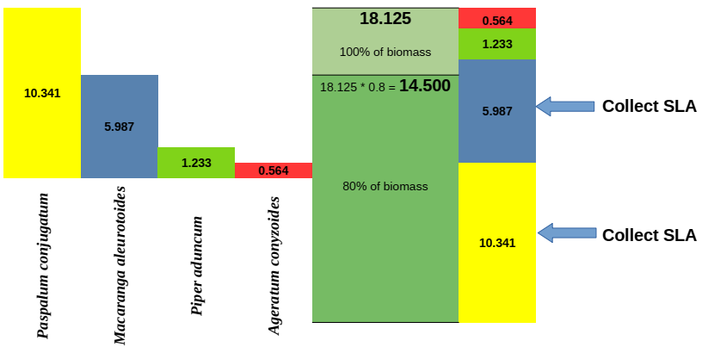

**11. For the selected species collect leaf frames (1 per species) and leaf disks (5 per species).**

* A leaf frame for feeding damage should be established for plant species whose biomass makes-up at least 80% of total biomass.
* The code for the frame should include the plot code, the first 4 letters of the genus, and two letters of the species name: O-G3-P1-MACAQU.
* Set up the camera and tripod so that the lens is just above the center of the board.
* The edges of the 50x50 cm square on the board should be visible on the screen and parallel to the edges of the screen.
* Remove all the leaves from the Zip Lock.
* Prepare the new paper label for the frame based on the label from the box.
* Take random sheets from the leaf sample and line them up on the board until all leaves are used or the 50x50 cm square on the board is filled.
* For extra large leaves, you can cut off the leaf blade and place the pieces on the board.
* Don't use leaves that have been damaged in any way other than by herbivores.
* For severely damaged leaves, place it as if it were an undamaged leaf.
* Choose a leaf of similar size to see how much space it'll take up.
* The leaves shouldn't overlap and should stay within the drawn 50x50 cm square and not cross the drawn line.
* After you have determined the weight of the leaves, take **5 leaf disks from the leaf sample**.
* Select only mature leaves that haven't been damaged in any other way than herbivory.
* Place the collected leaf disk sample in a separate zip-lock bag filled with silica gel. Label the bag with a field code and the name of the plant species.

**12. Collect soil samples**

* Put on latex gloves. At a given plot take 1 dm3 of soil from the control and fungicide plots using a small shovel.
* Take a sample from the center of the plot and one from the center of each quarter quadrant of the box, as shown in the figure below.
* Spread the soil on a piece of stretch plastic through a sterilized sieve, mix the sample, and take 3 soil samples.
* One sample is approximately equal to one spoonful of soil.
* Place each sample in a separate tea bag.
* Staple the tea bag together and put it in a zip-lock bag filled with 100 g of fresh silica gel.

* Label each bag with the location, garden number, plot type, date and the collector. The example code will look like this: W-G4-C-S1 (Wanang, garden number 4, control plot, first sample)